**PATFIN NURSERY AND PRIMARY SCHOOL, AKESAN, LAGOS STATE.**

**FIRST TERM EXAMINATION [ 2018 / 2019 ]**

**CLASS : Reception**

**NAME : _____________________________ SUBJECT: Science**

**INSTRUCTION : ANSWER CORRECTLY DURATION : 1 HOUR**

Colour these

**Sun**

xxzzzxzzzzzzzyyyy

xxzzzxzzzzzzzyyyy

**Fish**

**PATFIN NURSERY AND PRIMARY SCHOOL, AKESAN, LAGOS STATE.**

**FIRST TERM EXAMINATION [ 2018 / 2019 ]**

**CLASS : Reception**

**NAME : _____________________________ SUBJECT: Shapes and Colours**

**INSTRUCTION : ANSWER CORRECTLY DURATION : 1 HOUR**

Identify these shapes

_________________________________ ____________________________________

___________________________________ _________________________________

Say Circle and colour it Red

Say Square and colour it Blue

What colour is this ball?

What colour is the Cup?

**PATFIN NURSERY AND PRIMARY SCHOOL, AKESAN, LAGOS STATE.**

**FIRST TERM EXAMINATION [ 2018 / 2019 ]**

**CLASS : Reception**

**NAME : _____________________________ SUBJECT: NUMBER WORK**

**INSTRUCTION : ANSWER CORRECTLY DURATION : 1 HOUR**

Identify these numbers

**1 2 3 4 5**

Your text here

Section B

Trace number 1 – 5

**1 2 3 4 5**

**Write number 1 and 2**

|  |  |
| --- | --- |
| **1** | **2** |
|  |  |
|  |  |

**PATFIN NURSERY AND PRIMARY SCHOOL, AKESAN, LAGOS STATE.**

**FIRST TERM EXAMINATION [ 2018 / 2019 ]**

**CLASS : Reception**

**NAME : _____________________________ SUBJECT: Social Norms**

**INSTRUCTION : ANSWER CORRECTLY DURATION : 1 HOUR**

Name these items

What is this?

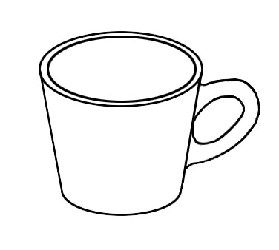

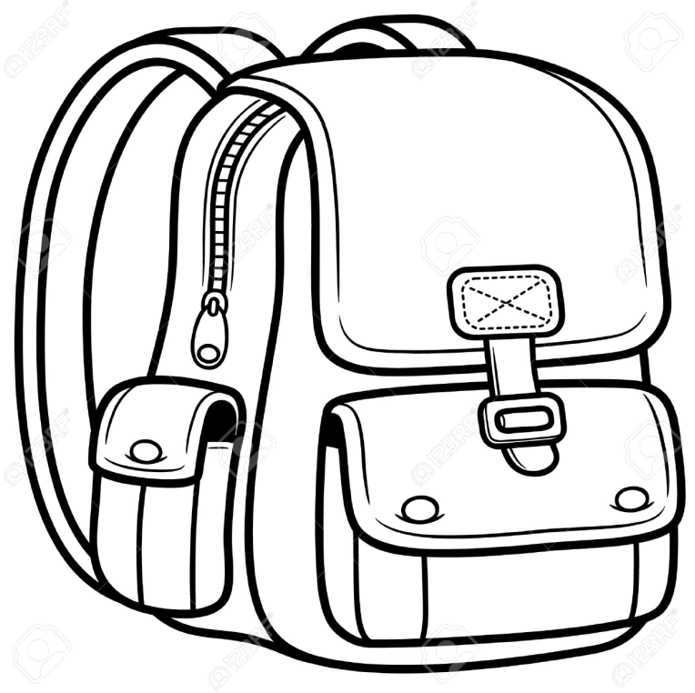

How to respond when called: -

**Teacher: _________________________________________**

**Pupil: ____________________________________________**

Mention the days in a week with the help of a rhyme

**PATFIN NURSERY AND PRIMARY SCHOOL, AKESAN, LAGOS STATE.**

**FIRST TERM EXAMINATION [ 2018 / 2019 ]**

**CLASS : Reception**

**NAME : _____________________________ SUBJECT: Rhymes**

**INSTRUCTION : ANSWER CORRECTLY DURATION : 1 HOUR**

**Recite the following rhymes**

1. Pawpaw is a kind of fruit.
2. When I was a baby.
3. How I love my little Gold Fish.
4. Baa Baa Black Sheep.
5. Hot, Cross, Buns.
6. A circle is round.
7. Rain Rain go away.

**PATFIN NURSERY AND PRIMARY SCHOOL, AKESAN, LAGOS STATE.**

**FIRST TERM EXAMINATION [ 2018 / 2019 ]**

**CLASS : Reception**

**NAME : _____________________________ SUBJECT: Letter Work**

Do the actions of letters sound a - i

Identify these letters

**A B C D E F G H I**

**Trace these letters**

**A B C D E F**